**Creating Microservices for account and loan**

**Creating Account Microservice:**

**Step 1:**

Open <https://start.spring.io/> and configure it as such :

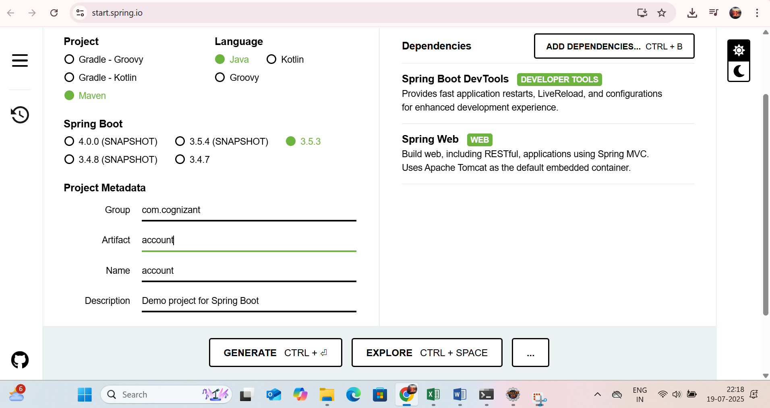

**Step 2:**

Open cmd and navigate to the project and type the command :

mvn clean package

**Step 3:**

Open Eclipse and import the project as Existing Maven project.

**Step 4:**

Create a new package in src\main\java\com.congnizant as controller and create an AccountController.java as such

**package** com.cognizant.account.controller;

**import** org.springframework.web.bind.annotation.*;

**import** java.util.Map;

@RestController

@RequestMapping("/accounts")

**public** **class** AccountController {

@GetMapping("/{number}")

**public** Map<String, Object> getAccountByNumber(@PathVariable String number) {

**return** Map.*of*(

"number", number,

"type", "normal",

"balance", 12000

);

}

}

**Step 5:**

Open AccountApplication.java and run as Java Application to get

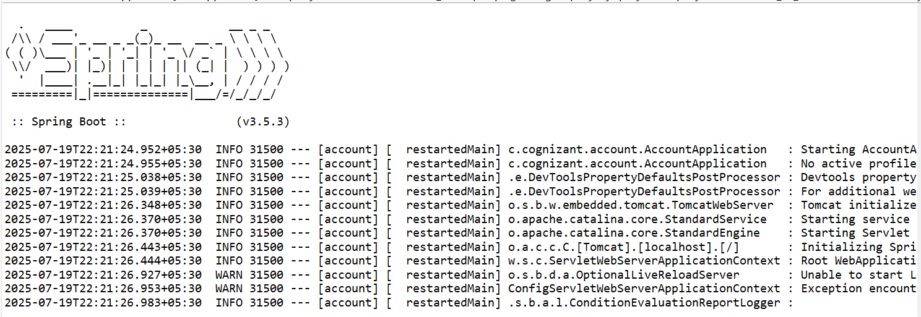

**Step 6:**

Open browser and type:

<http://localhost:8080/accounts/211422104039>

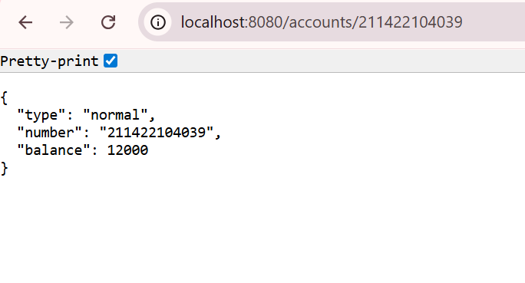

**Creating Loan Microservice:**

**Step 1:**

Open <https://start.spring.io/> and configure it as such :

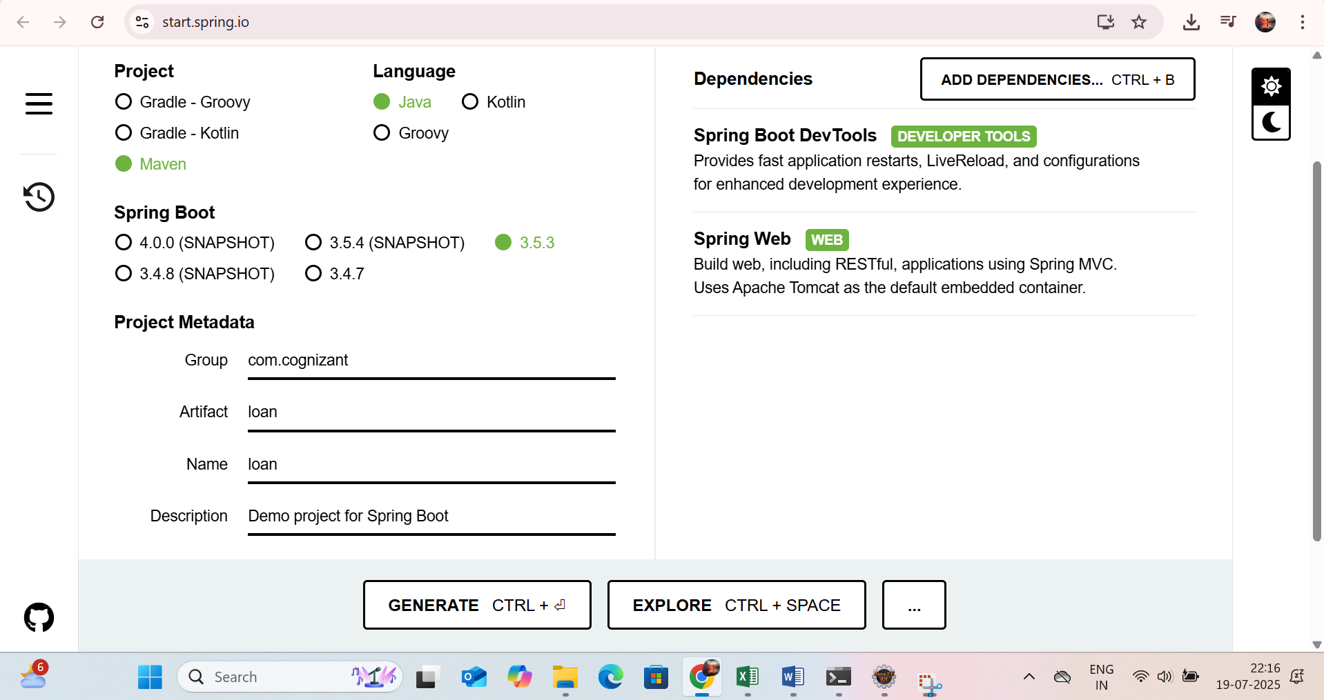

**Step 2:**

Open cmd and navigate to the project and type the command :

mvn clean package

**Step 3:**

Open Eclipse and import the project as Existing Maven project.

**Step 4:**

Create a new package in src\main\java\com.congnizant as controller and create an LoanController.java as such

**package** com.cognizant.loan.controller;

**import** org.springframework.web.bind.annotation.*;

**import** java.util.Map;

@RestController

@RequestMapping("/loans")

**public** **class** LoanController {

@GetMapping("/{number}")

**public** Map<String, Object> getLoanByNumber(@PathVariable String number) {

**return** Map.*of*(

"number", number,

"type", "home",

"loan", 12345

);

}

}

**Step 5:**

Open application.properties and edit the server.port = 8081 as 8080 is already in use



**Step 6:**

Open AccountApplication.java and run as Java Application to get

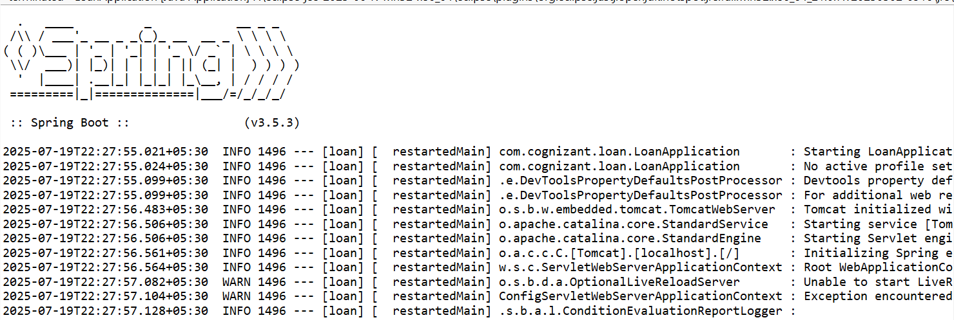

**Step 7:**

Open browser and type:

<http://localhost:8081/loans/211422104039>

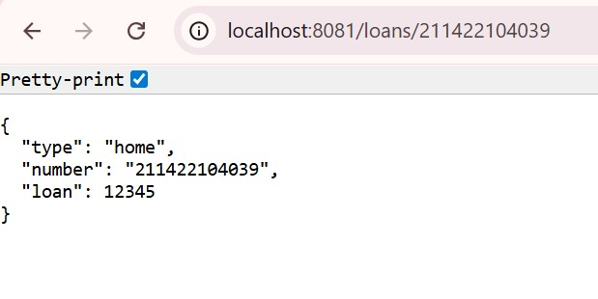

<http://localhost:8081/loans/123456789>

